### **3.1.1 Class Diagram**

A class diagram is an illustration that describes the system’s structure by representing classes, attributes, operation/methods of systems and the relationships among object.

The importance of performing class diagram in my project are:

* It helps in modelling the static view of an application.
* It can be used in time of construction and explains system’s responsibilities.
* It helps the programmer in the software coding and implementation.

**Report of notations in Class Diagram**

|  |  |  |
| --- | --- | --- |
| **Notation** | **Name** | **Function** |
|  | Class | Class is a blueprint for an object and a user defined data type that holds its own data members and member functions. |
|  | Association | It is a class that is part of an association relationship between two other classes. |

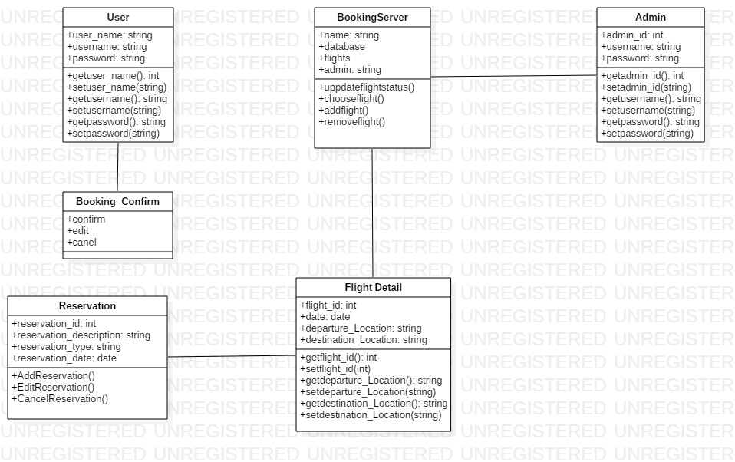

### **3.1.2 Data Flow Diagram**

A Data Flow Diagram is a visual description which represents the information that flows between various processes within a system. A neat, clear and nice data flow diagram can show a good amount of the system requirements graphically. The diagram can be automated, manual or the combination of both.

The importance of performing data flow diagram in my project are as follows:

* It helps in explaining the boundaries of the system.
* It helps to show the users how the data moves within a system.
* It is easy to understand for both technical and non-technical people.

**Report of notations in Data Flow Diagram**

|  |  |  |
| --- | --- | --- |
| **Notation** | **Name** | **Function** |
|  | Data Store | A data store is a holding place for information within the system. |
|  | Process | A process shows a transformation or manipulation of data flows within the System. |
|  | Source/Sink |  |
|  | Data Flow | A data flow is represented by a line, with arrowheads showing the direction of flow. |

**Login and Registration Data Flow Diagram**

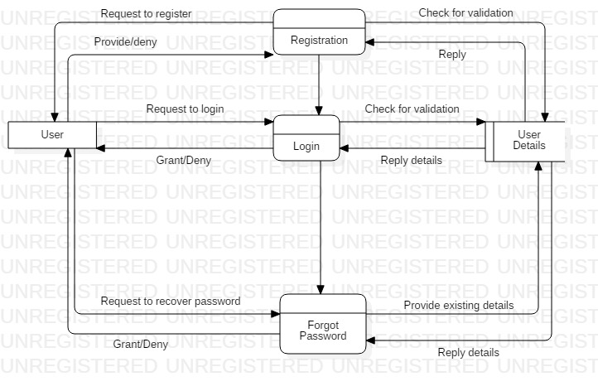

In the above Data Flow Diagram users are firstly requested to register for creating an account linked with the system by giving users details. Now they can get access into the system by providing the registered details and needed details. If the users forget the password, the system will help them in creating a new password, but only after the validation of their account ownership.

**Admin Action Data Flow Diagram**

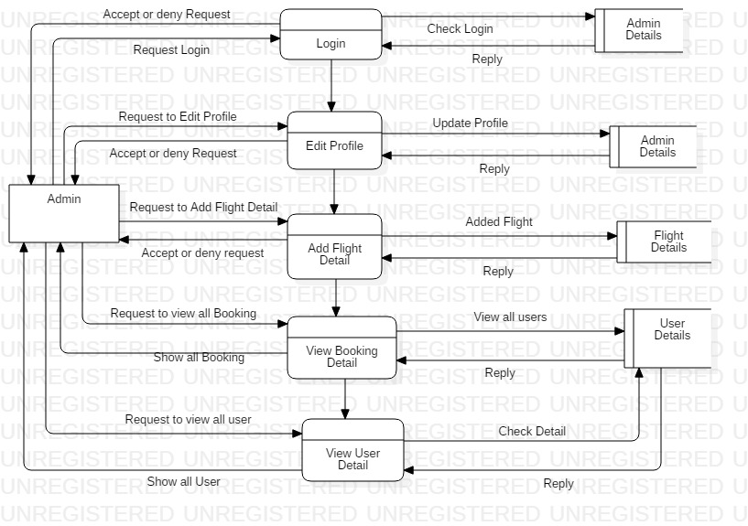

In the above DFD diagram, same like of the users, admin will also have the ability to login into the system, view admin details, flight details, and edit their profile. But the admin will have more additional ability than of the users. Admin will be able to add flight detail, view the booking details of the users, and also view the user details.

**User Action Data Flow Diagram**

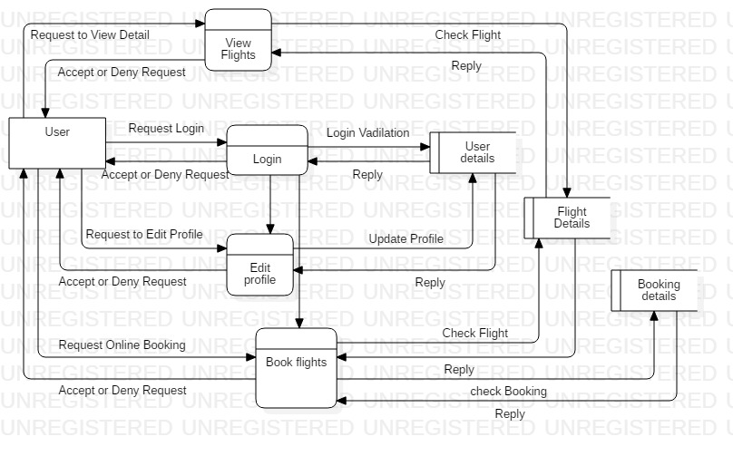

In the above DFD diagram, every users will be able to view the flights details. After the access to the system users can view their details, and they will also have the ability to edit their profile. They can also book the flights and view the booking details. For the successful complete of the function the users request has to be accepted in each process.